Rochefort 8 Clone Beer Recipe (All-Grain)
Posted on July 28, 2014 by David Ackley There have been 0 comments
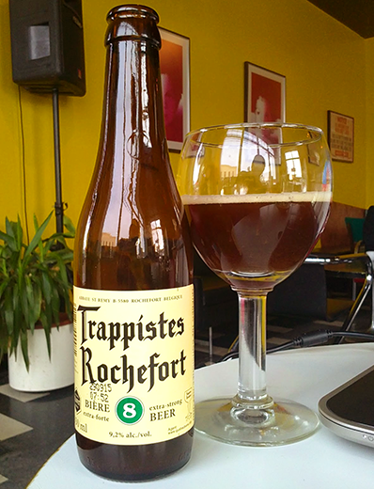Below you will find a Rochefort 8 clone beer recipe for all-grain. It has all the information you need for brewing the Rochefort 8 from scratch. A worthy project to take on.
About Rochefort 8
The Abbaye Notre-Dame de Saint-Remy in Belgium houses one of the world’s most highly regarded Trappist breweries – Rochefort. This isn’t your typical microbrewery. The Cistercian monks of Rochefort have been brewing beer there since long before the term “microbrewery” was born – 1595 to be exact. The brewery at Rochefort produces three beers of varying alcohol content:
- Rochefort 6 – Rochefort 6 is extremely rare, brewed just once a year. It has a light brown color with complex sweet, floral, and fruity flavors. 7.5% ABV.
- Rochefort 8 – Rochefort 8 is a deeper brown color at about 9.2% ABV, brewed year round since about 1960. It has a drier and richer flavor than 6, sometimes described as fig-like.
- Rochefort 10 – Rochefort 10 is the strongest of the three at 11.3% ABV, with spicy, earthy, and chocolate flavors.
All three beers consistently receive exceptional marks. (Just check BeerAdvocate and RateBeer.) Draft Magazine reviewedRochefort 8 and had this to say:
A playfully bubbly head and heavy aroma of alcohol spice, black currant and sourdough belie this brew’s murky brown appearance. Dark fruits invigorate the taste buds: Plum, figs and raisins pool in the middle of the tongue over a solid bread crust foundation. Black licorice and pepper add sharp edges to the fruity sweetness while alcohol warms the back of the throat. Rochefort’s dry finish cuts through the rich flavors, and leaves dark fruit notes on the tongue long after the swallow. 94 points.
Sounds enticing, right?
After digging around for some clone recipes I stumbled across a site in which a number of European homebrewers collaborated to develop a Rochefort 8 clone beer recipe. They then tasted each of the brews and compared them to the actual Rochefort 8. I’ve scaled the winning clone recipe to a five-gallon batch, converted the measurements to English units, and made some minor adjustments based on the brewers’ feedback.
Be sure to prepare a healthy yeast starter to get the level of attenuation needed for this brew.
Good luck!
Rochefort 8 Clone Beer Recipe (All-Grain)
(5-gallon batch)
Specs
OG: 1.080
FG: 1.010
ABV: 9.2%
IBU: 23
SRM: 35
Ingredients
10.5 lbs. Pilsner malt 4760g
1 lb. 9 oz. Caramunich malt (type II) 408g + 255g 665g
1 lb. 3 oz. Dark candi sugar 408g + 85g 495g
8.4 oz. Special B malt
8.4 oz. Flaked corn
2.5 oz. Carafa III
1 oz. Styrian Goldings hops at :75 (4.2 AAUs)
.67 oz. Hallertau hops at :30 (2.35 AAUs)
.33 oz. Hallertau hops at :5 (1.16 AAUs)
.33 oz. crushed coriander seed at :5
2 packs Wyeast 1762: Belgian Abbey II ale yeast
Corn sugar for priming
Directions
At least 12 hours before brewing, pitch two packs of Wyeast 1762 into a 2L yeast starter. On brew day, mash grains in 3.5 gallons of water. Hold at 140-144˚F for 30 minutes, then raise to 154˚F for 60 minutes. Raise to 167˚F for mash out, then sparge with 172˚F water to collect about seven gallons of wort. Stir in Belgian candi sugar and boil for 90 minutes, adding hops and coriander according to schedule. Cool wort to 70˚F and ferment at 69-74˚F. Prime with corn sugar and bottle condition for 2-4 months or longer.
Do you have a Rochefort 8 clone beer recipe you'd like to share? Are you a fan of Trappist beers? Also consider brewing this Westmalle Tripel clone.

